 | Intelligent Card-Credit Card Onboarding  Technical Design Document  1.0
 | Prepared By / Last Updated By | Reviewed By | Approved By
Name | Sivaranjani N  Sujini S P  Sowmyaa Devi K  Shahid Ahmed F | Thiruppathi | Thiruppathi
Role | Team Member | Trainer | Scrum Master
Signature
Date

Table of Contents

1.0 Introduction 3
1.1 Purpose of this document 3
1.2 Scope 3
1.3 Intended Audience 3
1.4 Definition & Acronyms 3
2.0 Conventions and Standards Followed 4
3.0 Assumptions, Dependencies and Risks 4
3.1 Assumptions: 4
3.2 Dependencies: 4
4.0 Schematic Diagram 4
5.0 Use Case Realization 5
5.1.1 User Registration 5
a. Functional Requirement 6
b. UI Validations 6
c. UI Controls 7
d. UI Methods Definition 8
e. UI Design 9
6.0 Database Design 10
6.1 Data Model 10
6.2 Tables Structure 10
7.0 Change Log 13

Introduction

Purpose of this document
The purpose of the detail design document is to define the detailed design for all the components of Intelligent Card-Credit Card Onboarding that are specified in the Business Requirement/Use case document. All the low level components, interfaces and integrations are detailed out in this document.

Scope
This sub-section shall state the scope of this detailed design document
• Create and maintain member information.
• Create and maintain credit card information.
• Create and maintain bill information.

Intended Audience
The intended audience for this document are
- Developers, testers, other associates in the project
- Technical lead, Scrum Master
- Product Owner

Assumptions, Dependencies and Risks

Assumptions:
- Once the application is built the intelligent credit card onboarding admin team will manually load the user list into the system.
- There will be no concurrent users for the application. The User profile will be maintained by the User.
- Any changes to the design mentioned in the BRD would be taken as a Change Request

Dependencies:
- Availability of database design characteristics & access shall be defined by the
- Resource availability throughout each of the sprint

Schematic Diagram
A schematic, or schematic diagram, is a representation of the elements of a system using abstract, graphic symbols rather than realistic pictures. It gives an overview of overall system
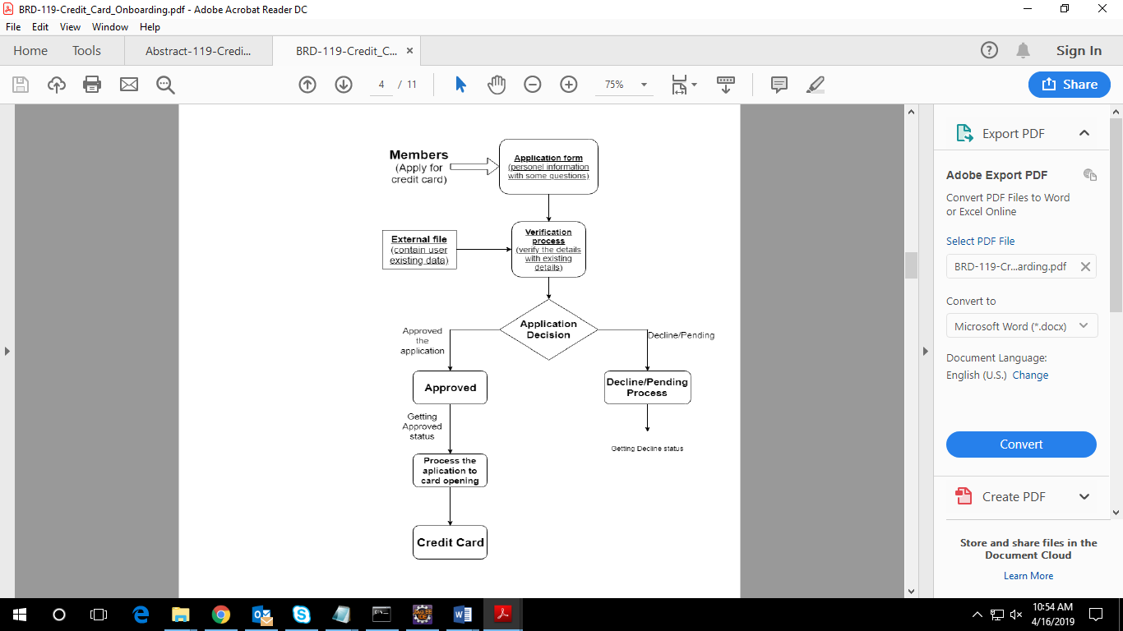

Use Case Realization

User Registration

Functional Requirement
. Login Page checks the authentication of the user and based on his role, directs the user to the respective page. User will be provided with links to view whether his/her card is accepted or rejected.

UI Validations
- User Id and Password fields are mandatory.
- Invalid User Id and / or password should not allow the user to get into the system

UI Controls
# | UI Component | Type | Name | Details
1 | Username | Text Field | username | To enter username
2 | Password | Password | password | To enter password

Method Name | Parameter | Details
registerButton_Click | object sender, EventArgs e | Allows the user to register
HomeButton_Click | object sender, EventArgs e | Loads the Homepage after registration is done successfully.
submitButton_Click | object sender, EventArgs e | Allows the user to login into application form page.
ResetButton_Click | object sender, EventArgs e | Resets all fields given by user.
submitButton_Click | object sender, EventArgs e | Allows the admin to login into application form page.
ResetButton_Click | object sender, EventArgs e | Resets all fields given by admin.
Page_Load | None | None
Status_click | object sender, EventArgs e | Allows the user to view the accepted/rejected status.

UI Methods Definition

UI Design
- 

- 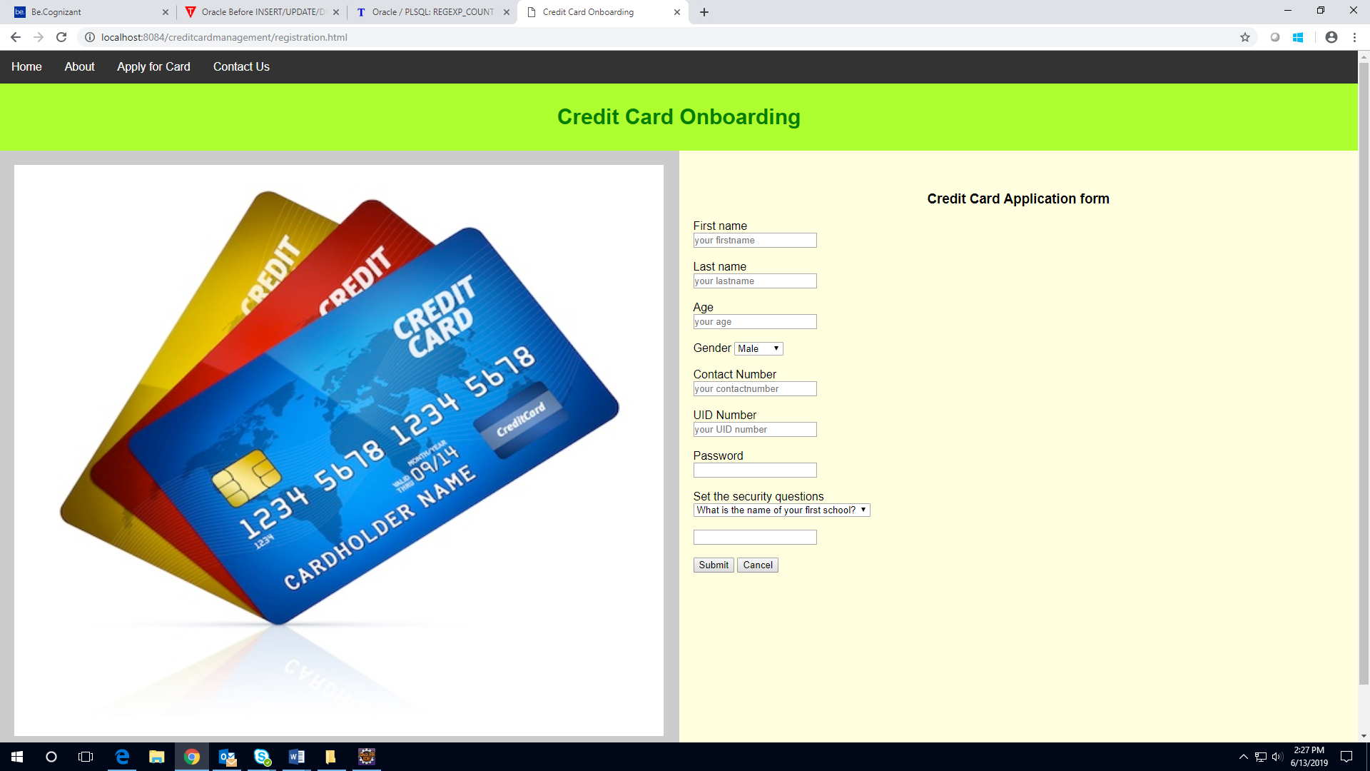
- 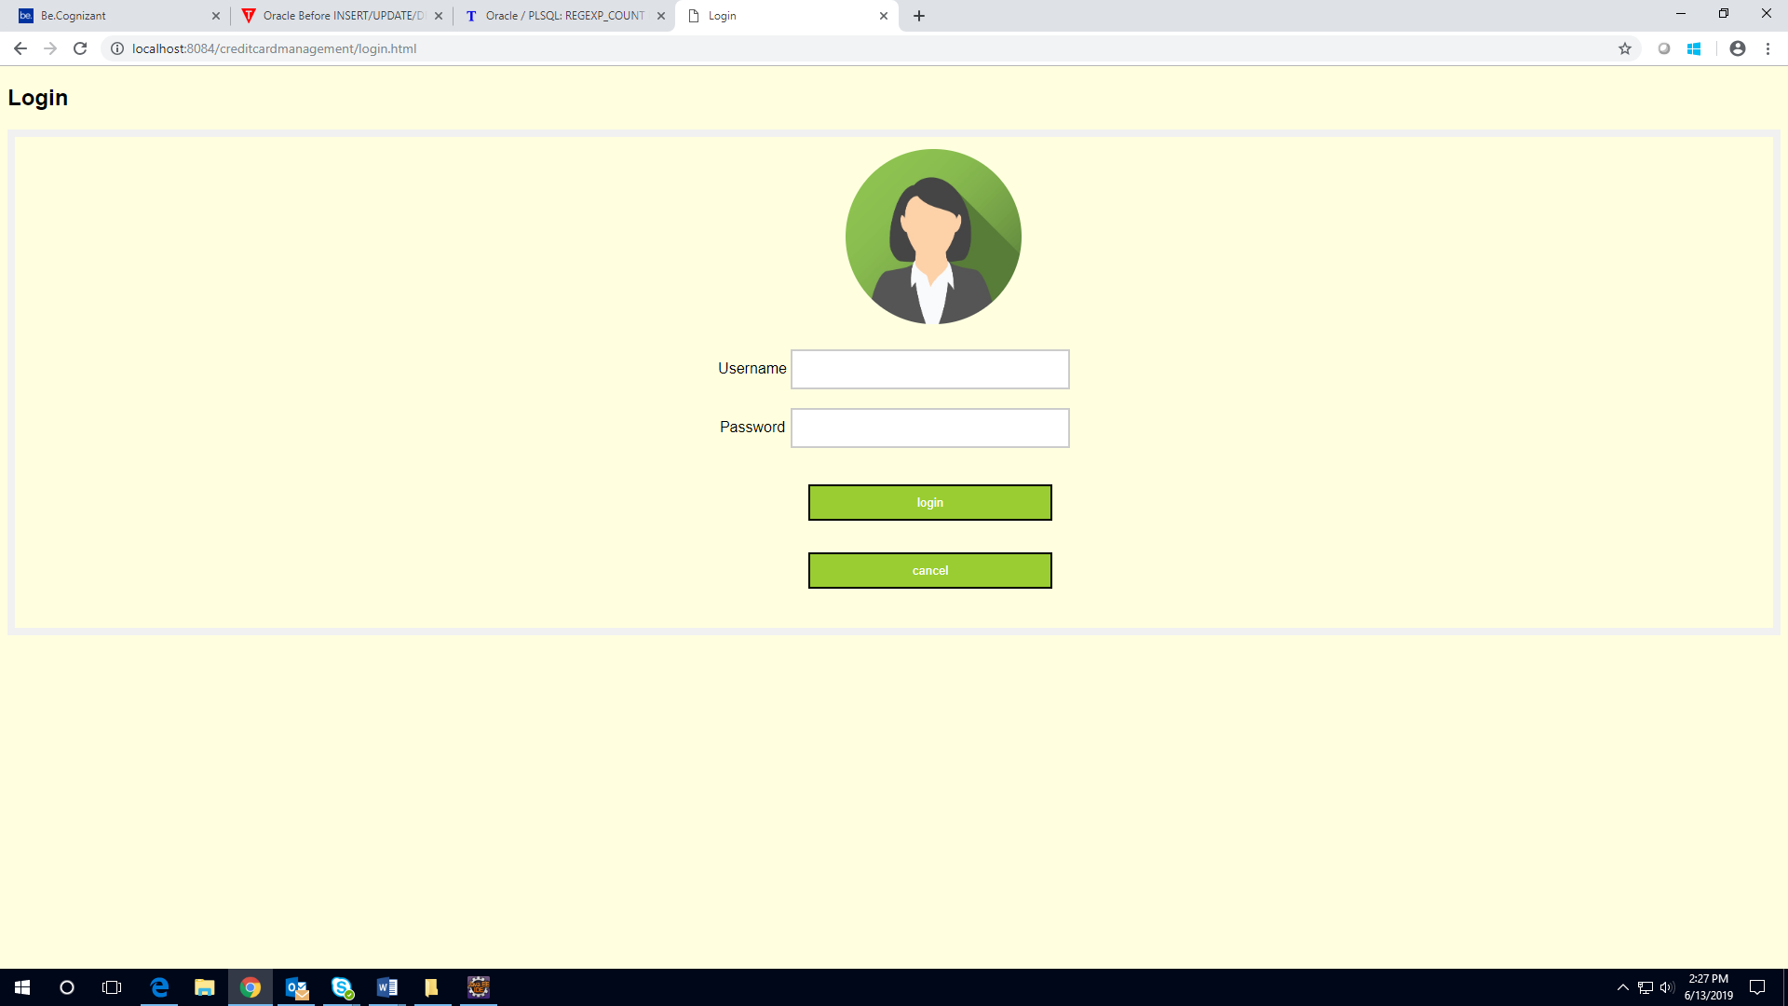

- 

- 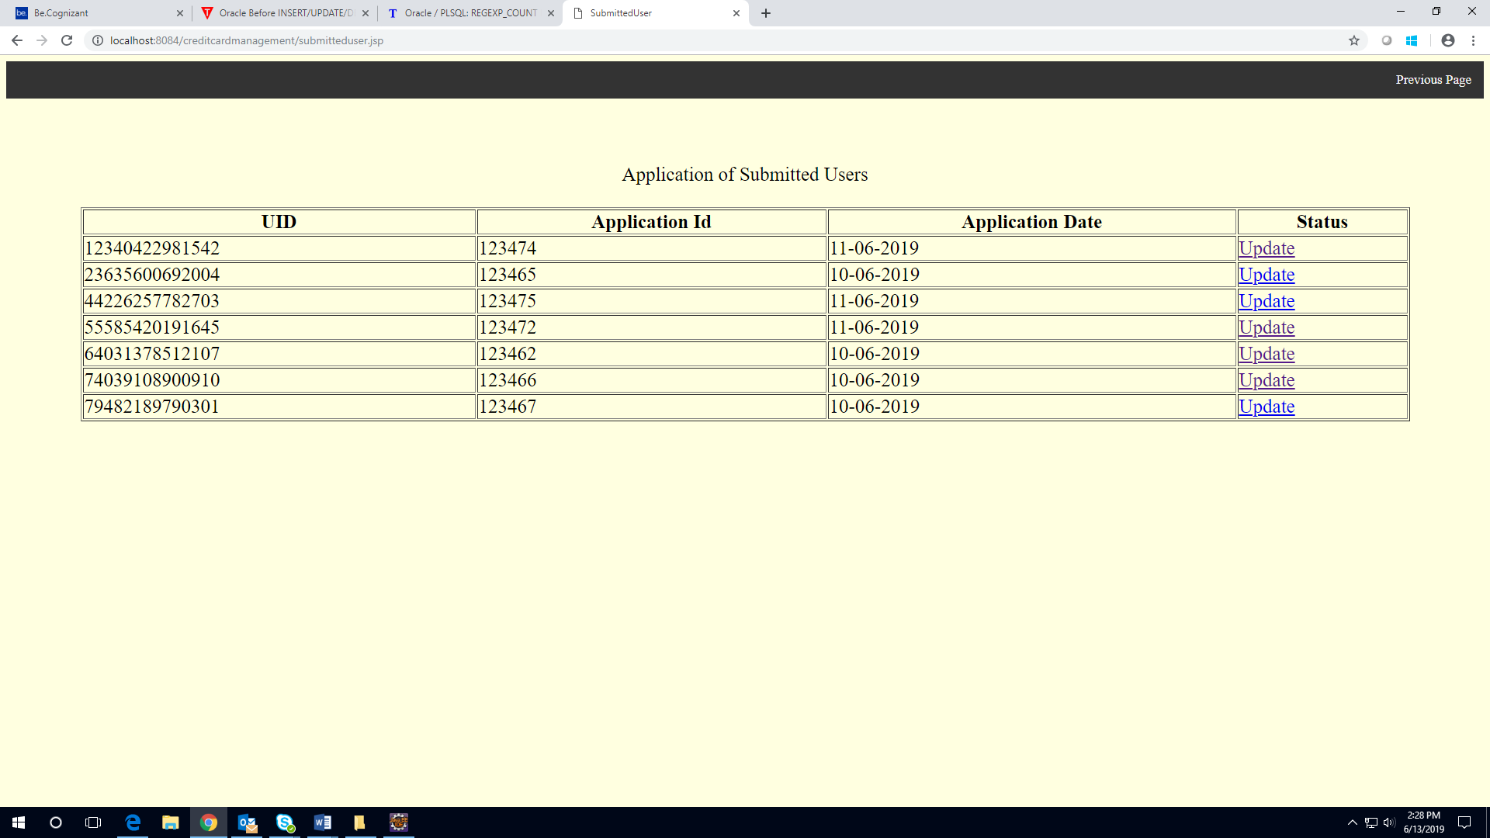

- 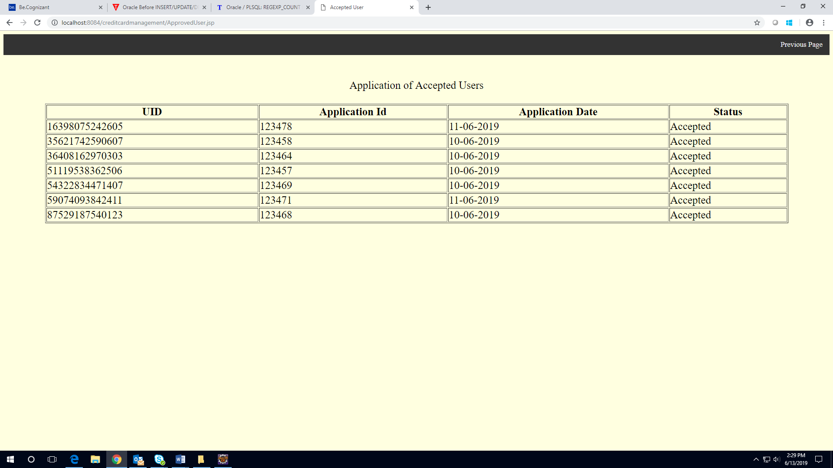

- 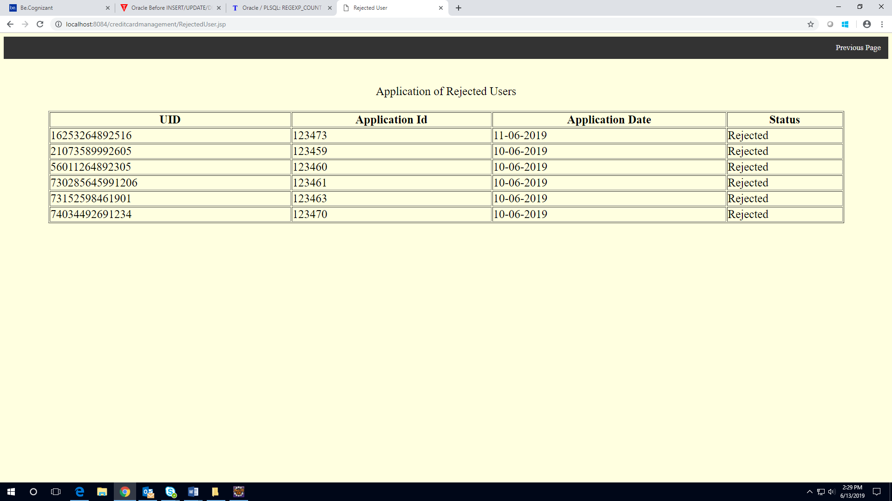

- 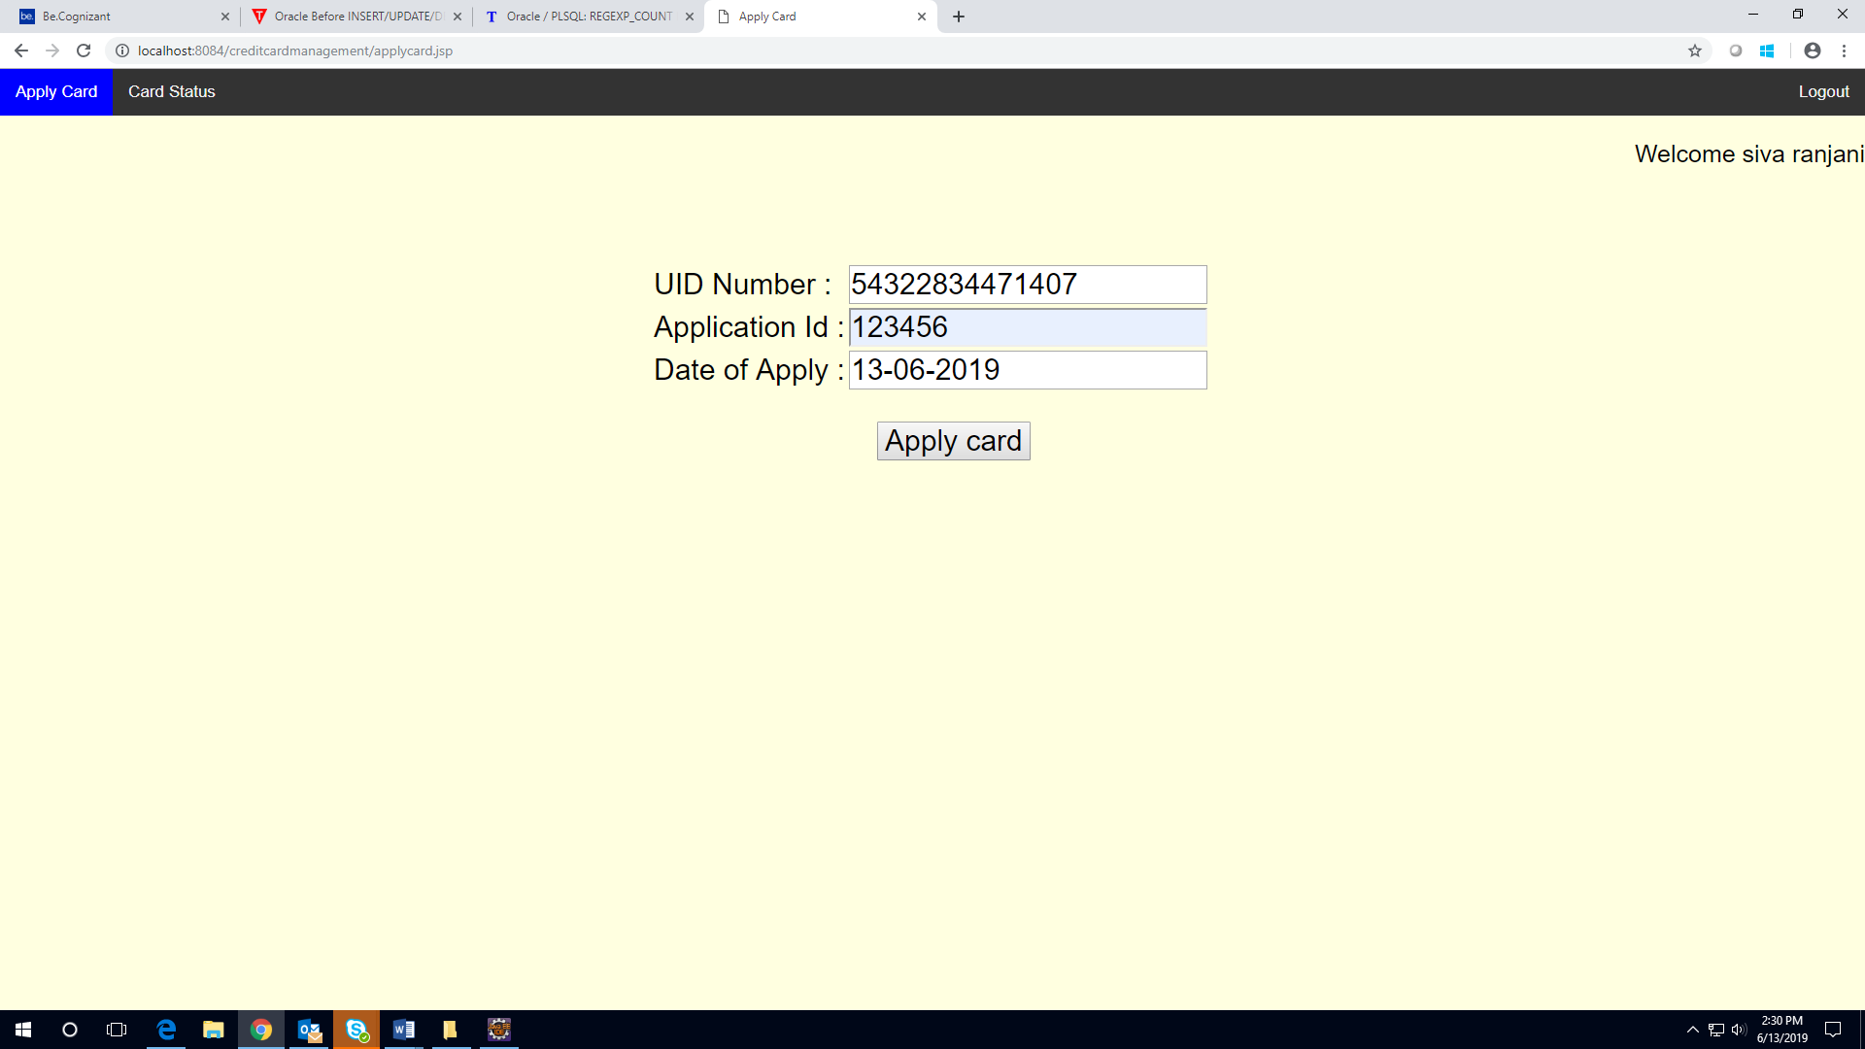

- 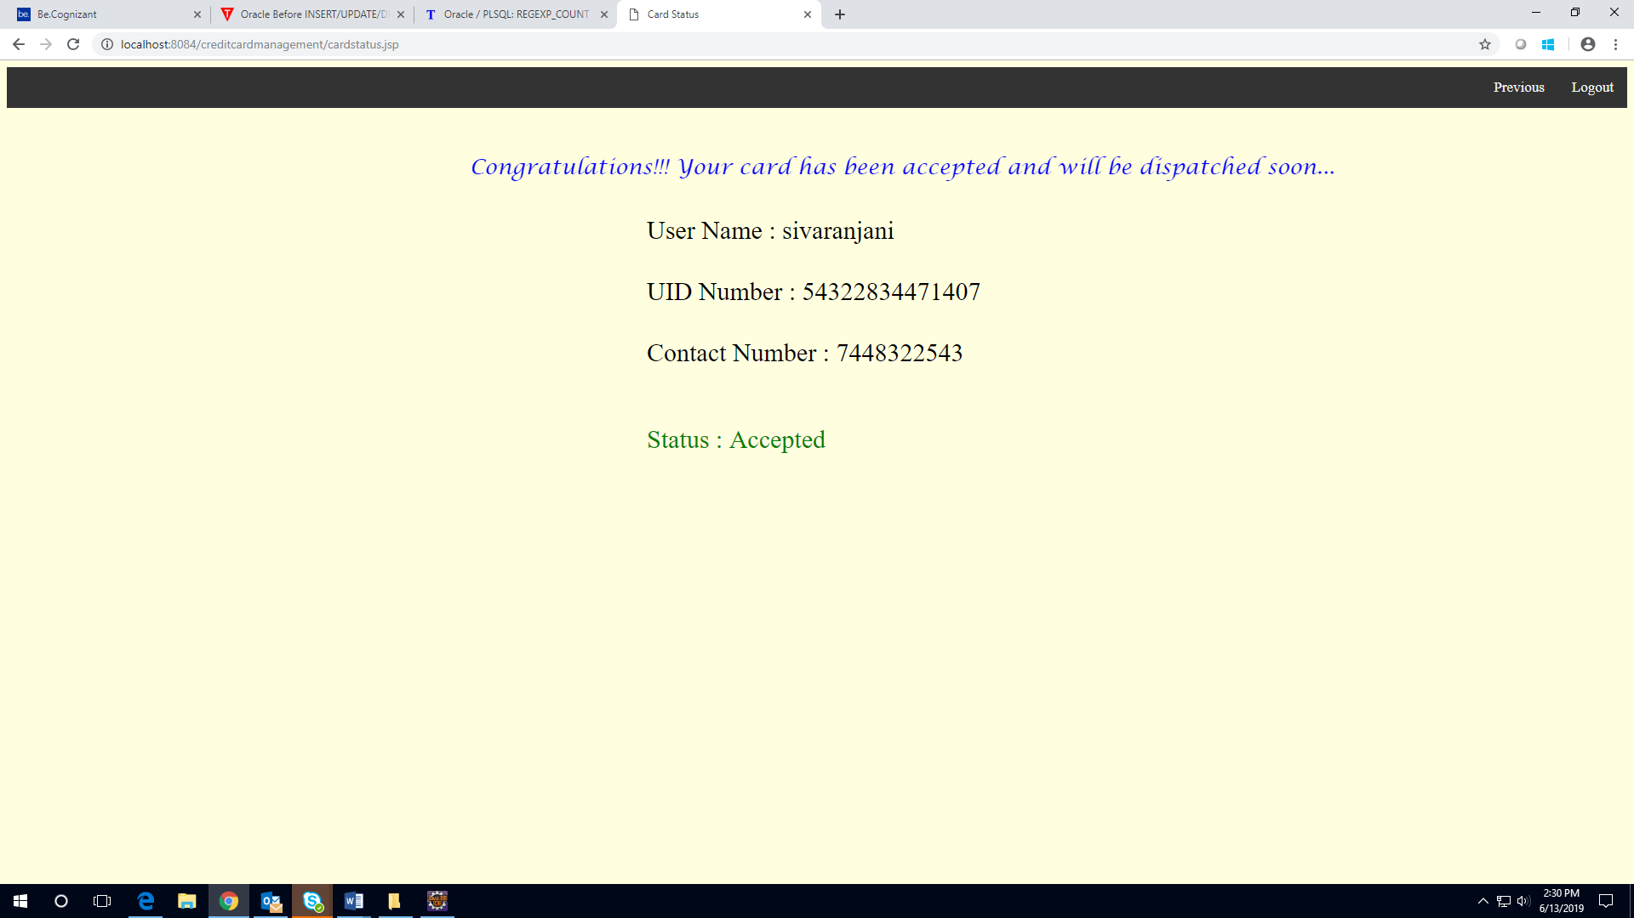

- 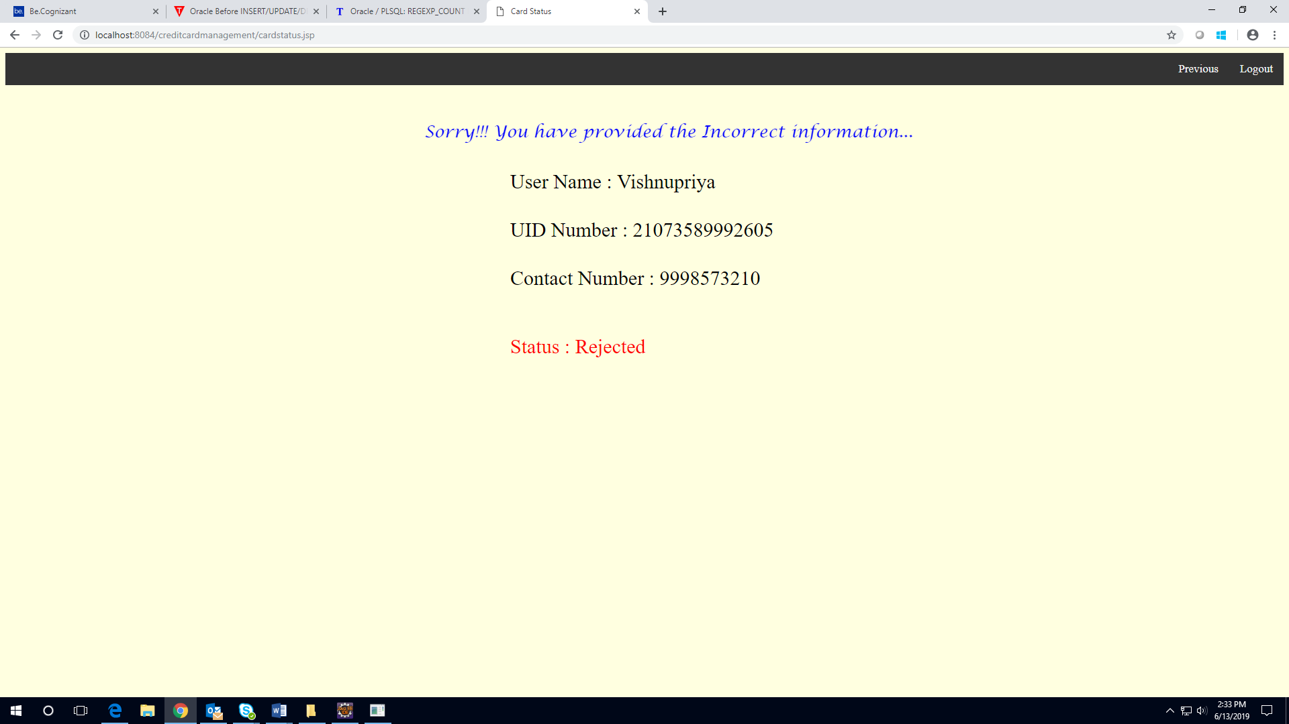

- 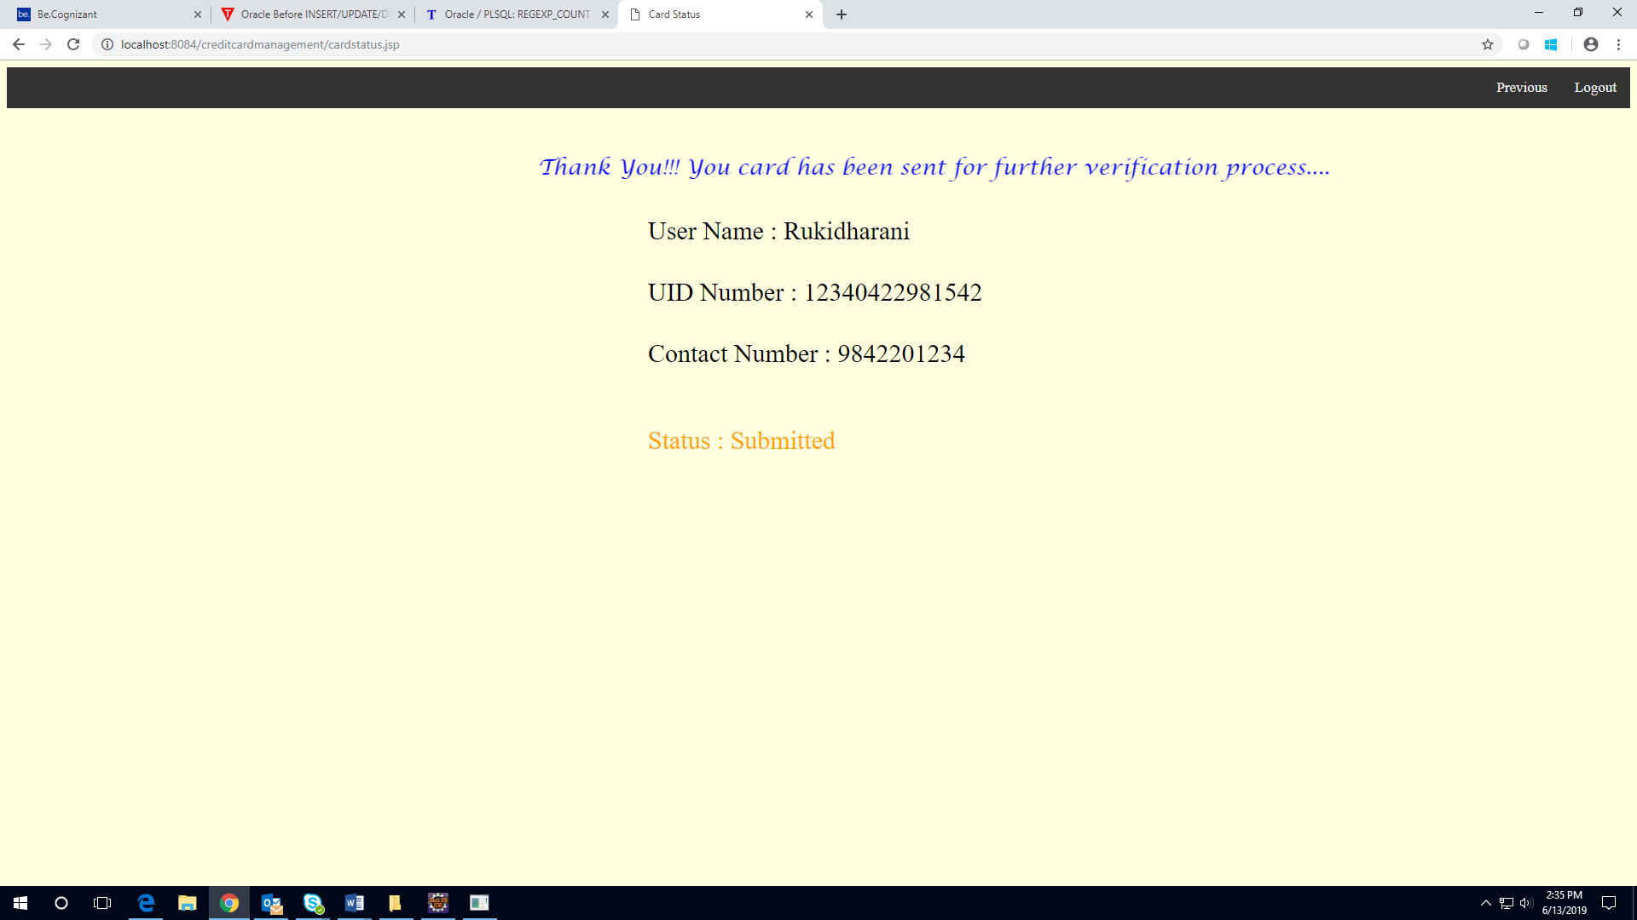

Database Design

Data Model

Tables Structure
User Registration:
Column Name | Data Type | Length | Nulls
First Name | nvarchar | 50 | N
Last Name | nvarchar | 50 | N
Age | Int | 5 | N
Gender | varchar | 10 | N
Contact Number | varchar | 10 | N
UID Number | varchar | 10 | N
Password | nvarchar | 50 | N
Set the security questions | nvarchar | 50 | N

User login:
Column Name | Data Type | Length | Nulls
User name | nvarchar | 50 | N
Password | nvarchar | 50 | N

User application form:
Column Name | Data Type | Length | Nulls
UID Number | varchar | 50 | N
Application Id | int | 50 | N
Date of Apply | Date | 50 | N

Admin form:
Column Name | Data Type | Length | Nulls
First Name | nvarchar | 50 | N
Last Name | nvarchar | 50 | N
Age | Int | 5 | N
Gender | varchar | 10 | N
Contact Number | varchar | 10 | N
UID Number | varchar | 10 | N
Password | nvarchar | 50 | N
Application id | int | 50 | N
Date of submission | Date | 50 | N
Status | nvarchar | 50 | N

Change Log
Please note that this table needs to be maintained even if a Configuration Management tool is used.
Version Number | Changes made
V1.0 | <First version>
V1.1 | <If the change details are not explicitly documented in the table below, reference should be provided here>
V1.1 | Page no | Changed by | Effective date | Changes effected
V1.2 | <If the change details are not explicitly documented in the table below, reference should be provided here>
V1.2 | Page no | Changed by | Effective date | Changes effected

